**PRACTICAL NO. :- 02**

1. **Simple Queries with MongoDB.**

* **To Find age > 40 using find() query .**

Query : db["emp"].find({age :{$gt : 40}},{_id :0})

**OUTPUT :**

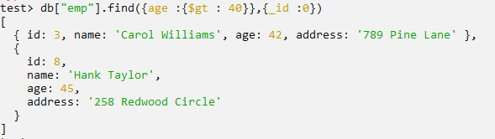

* **To Find age < 40 using find() query**

Query db["emp"].find({age :{$lt : 40}},{_id :0})

**OUTPUT :**

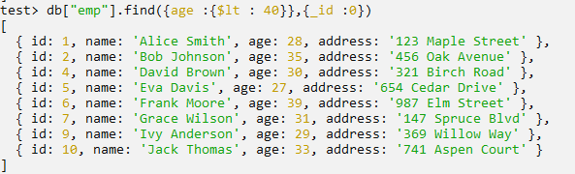

* **To Find age is 35 and 39 using find() query**

Query : db["emp"].find({age : {$in :[39,35]}},{_id :0})

**OUTPUT :**

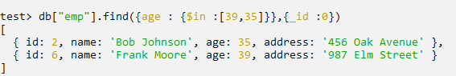

* **To Find age is 35 and 39 using find() query**

Query : db["emp"].find({age : {$gte :20}},{_id :0}).limit(5)

**OUTPUT :**

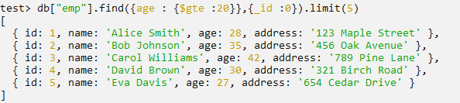

* **Finds up to 5 products whose address contain "elm" (case-insensitive), sorted by age from the highest to lowest.**

Query : db["emp"].find({name :{$regex :"Alice" , $options : "i"}},{_id :0}).limit(5)

**OUTPUT :**

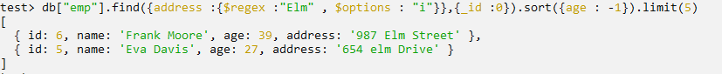

* **Counts all documents matching age > 30. Use estimated DocumentCount() for quick count with filter.**

Query : db["emp"].countDocuments({age :{$gt : 30}})

**OUTPUT :**

